Again, really looking good guys. Nice work.

Introduction

The iMedical that appears when you first visit the site is good thanks.

Login / Register pages – very nice. Please remove black trim around boxes on both and password page.

Home Page

Menu wording in black. Box looks good. Homepage is good thanks.

Section: **Why use imedical in your Practice?** Some additional wording:

**Easy to use**

Your Practice staff can access information and documentation quickly and easily. We have designed iMedical for efficient use in a fast-paced Practice environment. Simply log into iMedical and leave it open in your browser throughout the day and consult iMedical as and when you need it. Useful policies & procedures, templates and checklists available at your fingertips. Easy!

**Best Practice**

iMedical outlines a best practice approach across several key areas within your Practice and the best means of implementation and follow up. iMedical will form the basis for your Practice to adopt a quality management system and manage ongoing compliance and performance. Depending on the subject area, Recommended Best Practice comprises ready-made policies for your Practice to adopt and implement such as the Staff Handbook in the Human Resources section, a Health & Safety Statement in the Health & Safety section and the Infection Prevention & Control Policy in the Infection Prevention & Control section. Compliance made easy!

**Up-to-date**

iMedical is maintained and updated by us periodically so you can be sure of working with up-to-date information and documentation. The iMedical feedback section promotes feedback from all users of iMedical whereby we can understand what works well and what might work better - this means that your Practice will benefit from ongoing feedback we receive from our entire user base that we like and believe will be useful to all iMedical users.

**Value for money**

iMedical is made available on an annual subscription basis which means no prohibitive upfront costs. To ensure unbeatable value, we have made iMedical available at an extremely competitive price. We must be crazy!

**Education**

iMedical is the perfect tool for providing structured inductions, staff training and consistency of process and operations in your Practice. Simply use iMedical as a reference point to induct, educate and train Practice staff across key practice areas which will ensure that all Practice staff sing from the same hymn sheet.

**Explore iMedical Plans and Pricing**

Need to update the Plans & Pricing section when you click on it in the main website. Same box layout but redirected to the Register section by clicking Get Started which is different from Sign Up within the Add Subscription in iMedical proper.

**PLANS AND PRICING**

Choose a plan that works best for you.

|  |  |  |  |  |  |  |  |
| --- | --- | --- | --- | --- | --- | --- | --- |
| STANDARD  €500  **Ex VAT**  iMedical (1 Year)  Automatic Updates  7 Users   |  | | --- | | **Get Started** | |  | **BUSINESS**  **€950**  **Ex VAT**  iMedical (1 Year)  Automatic Updates  8 Users  1-Day Onsite Consultancy  (€500 Ex VAT each additional day)   |  | | --- | | **Get Started** | |  | PREMIUM  €1,750  **Ex VAT**  iMedical (1 Year)  Automatic Updates  9 Users  Website Development  (€3,000 Ex VAT including tailored website content)   |  | | --- | | **Get Started** | |

* Slight further change to the footer. Positive Health logo to be without the box in front. Just the text please.

Bottom of Form

Features

* Any other more relevant icons we could use for Checklists and Templates? If not, then no worries.

FAQs

In the FAQ section of the website, need to reduce the size of the font in the header of the drop-down boxes just a little – a tad too big.

Sent separate email with new FAQs. Thanks.

Dashboard

Like the revised Dashboard. Some comments:

* **Top strip** – can we remove the dark line between the white box above and the light blue box below?.
* Calendar/ Weather strip and News & Announcements need to work.
* Search icon and page is good thanks. When the search page appears, can we make it the same layout as search page on <https://www.capitalphysio.com/patient-information/> - need to click on search icon in top right. Looks a bit slicker.

Knowledge Box

Like the Knowledge Box main page. Good work.

When you click on one of the sections, I like the look of this. Some comments:

* The 6 light blue boxes (RBP, Our Practice Differences etc.) need to be better aligned. The line above RBP is off compared to the navy menu on the left when minimised whilst there is a gap under Resources. Can we please align?
* I like the alignment of the dropdown boxes on the right once content is inserted. Just wondering whether solid box drop downs are too much given the left menus. See drop-down boxes on <https://www.capitalphysio.com/patient-information/> Similar to those on the FAQ page on iMedical website i.e. no solid colour unless clicked on. Easier to read.

Need to discuss the issues with formatting when including text.

My Account

Look and feel is much better thanks.

**Profile**

* Add / Edit User – need to include section for Ms. in Title section. Will be accused of discrimination ☺
* We can remove position type and retain the dropdown boxes for role only. Save duplication.
* Can we make the background white instead of grey on this page and just have the light grey trim around the profile box i.e. all white background including box but with grey outline?
* The avatar blue shade to be navy colour please. It is a different blue colour.

When you click on any of the blue buttons on the right can we have the form fill the right side of the page, see below with white background. We can remove the light blue headers on all the current pop up forms and go with white background and grey trim. Buttons in light blue. I can explain further if needed.

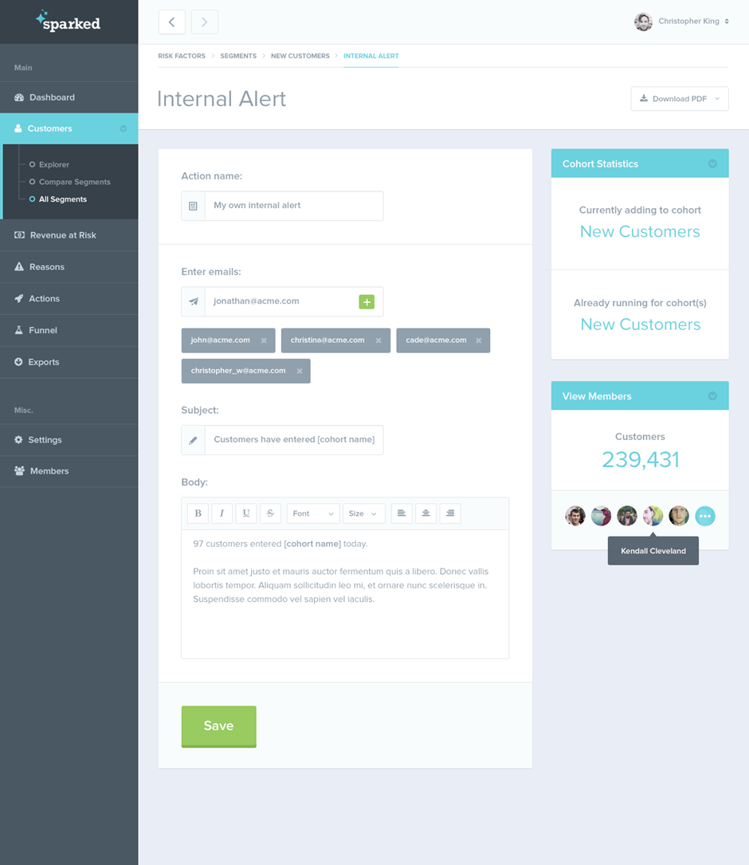

**Feedback**

* Can we make the background white instead of grey on this page and just have the light grey trim around the text box i.e. all white background including box but with grey outline? Need to include heading ‘Feedback’ to be in larger text and in black colour in the centre at the top.

**Users**

* Need to make the black boxes on the right under **Actions** a bit smaller, currently too big.
* Text to be left aligned.
* Include a heading for Users and then a filter underneath.

USERS

*Include filter here*

|  |  |  |  |  |  |  |  |  |
| --- | --- | --- | --- | --- | --- | --- | --- | --- |
| Title | First Name | Surname | Gender | Model | Role | Phone | Reg. Number | Actions |

When you click on any of the black buttons on the right can we have the form fill the right main side of the page as outlined above.

Title and Gender appears in User section in small caps which needs to be capitalised.

Practice Account

**Profile / Billing & Payment / Practices**

**Profile**

* Avatar to navy please.
* Add / Edit User – need to include section for Ms. in Title section.
* We can remove position type and retain the dropdown boxes for Role. Save duplication.
* When you complete a form and there is an error, the form clears – **any way that we can retain the correct info whilst highlighting the error** – save people filling entire form again which may be a frustration.
* There is provision to send a message to a user – does this go to their nominated email and from which account – a designated iMedical administrator email? Is this email facility only available to iMedical or the practice administrator?
* Curenly available slots for new users 5 – slight typo in bottom right of the page.
* In Administrator settings – does the ‘x’ mean they are the administrator and the tick mean they can be but are not?

**Billing**

* The **update billing info** and **view payment history** buttons do not work?

* Under billing address, can we make specific to Ireland by reference to County and Eircode rather than US terminology that looks to be included?

**Practices**

* Need to make the black boxes on the right under **Actions** a bit smaller, currently too big.
* Text to be left aligned.
* Include a heading for Practices and then a filter underneath.

Practices

*Include filter here*

|  |  |  |  |  |  |  |
| --- | --- | --- | --- | --- | --- | --- |
| Name | Details | Address | Fax | Email | Site | Actions |

When you click on any of the black buttons on the right can we have the form fill the right main side of the page as outlined above.

Add Subscriptions

Need to update this section for the below i.e. smaller boxes with text above.

**PLANS AND PRICING**

Choose a plan that works best for you.

|  |  |  |  |  |  |  |  |
| --- | --- | --- | --- | --- | --- | --- | --- |
| STANDARD  €500  **Ex VAT**  iMedical (1 Year)  Automatic Updates  7 Users   |  | | --- | | **Sign Up** | |  | **BUSINESS**  **€950**  **Ex VAT**  iMedical (1 Year)  Automatic Updates  8 Users  1-Day Onsite Consultancy  (€500 Ex VAT each additional day)   |  | | --- | | **Sign Up** | |  | PREMIUM  €1,750  **Ex VAT**  iMedical (1 Year)  Automatic Updates  9 Users  Website Development  (€3,000 Ex VAT including tailored website content)   |  | | --- | | **Sign Up** | |

Content Editor

* Need to make the black boxes on the right under **Actions** a bit smaller, currently too big.
* Text to be left aligned.
* Need to include filter.
* Need to sort out formatting and additional formatting tools.

Create button to remain

*Include filter here*

|  |  |  |  |  |  |  |
| --- | --- | --- | --- | --- | --- | --- |
| Name | Details | Address | Fax | Email | Site | Actions |

When you click on **Create** button can we have the form fill the right main side of the page as outlined above.

Blog (within iMedical)

* Same layout and filter as Content Editor.

Report a problem

* Can we make the background white instead of grey on this page?
* Change **Report a Problem** heading to black.
* Text to be left aligned.
* Include asterixs on all boxes please.
* Include small space above Send button please.